NAME: S. DHARANI
REG NO: 192472364
COURSE CODE: DSA0401
NUMPY / PANDAS ANALYSIS – QUESTIONS AND ANSWERS
QUESTION 10: MONTHLY SALES LINE PLOT AND BAR PLOT
AIM:
To visualize monthly sales using line and bar plots in Matplotlib.
ALGORITHM:
1. Import Matplotlib.
2. Create month and sales lists.
3. Use plt.plot() to draw a line plot.
4. Use plt.bar() to draw a bar plot.
5. Add titles, labels and display both plots.
CODE:
import matplotlib.pyplot as plt
months = ["Jan", "Feb", "Mar", "Apr", "May", "Jun"]
sales = [120, 150, 130, 180, 200, 220]
plt.plot(months, sales, marker="o")
plt.title("Monthly Sales - Line Plot")
plt.xlabel("Month")
plt.ylabel("Sales")
plt.grid(True)
plt.show()
plt.bar(months, sales)
plt.title("Monthly Sales - Bar Plot")
plt.xlabel("Month")
plt.ylabel("Sales")
plt.show()
INPUT:
Months = Jan to Jun
Sales = [120, 150, 130, 180, 200, 220]
OUTPUT:
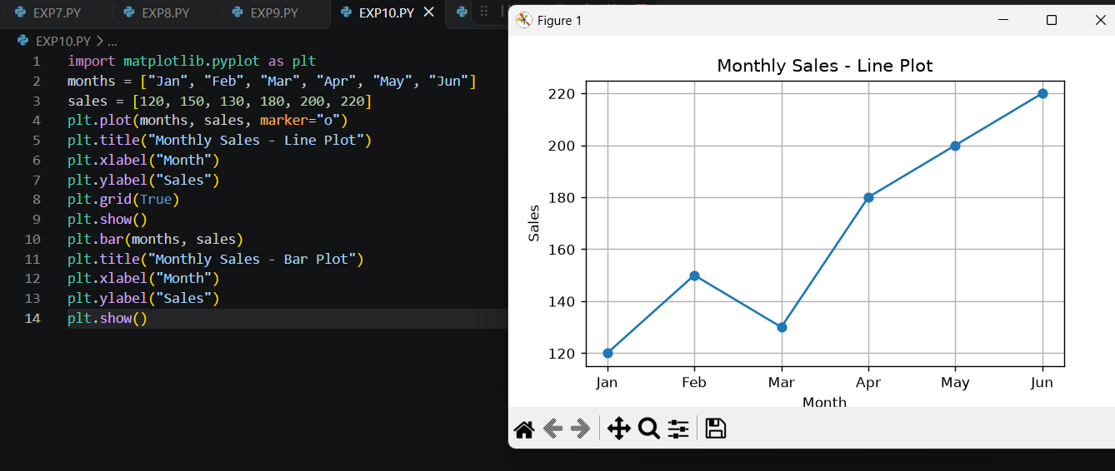
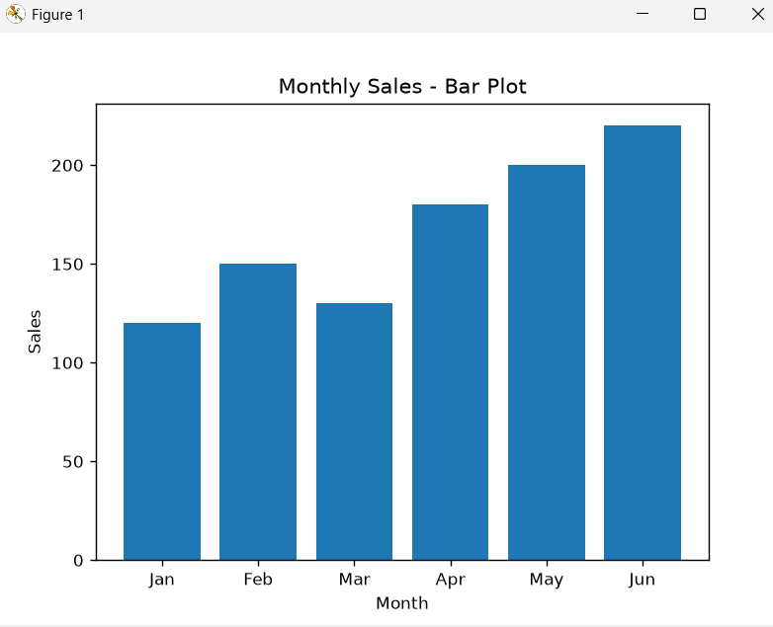
RESULT: Line and bar plots were created successfully.

